**WEEK 3:**

Write SQL Select Statements for the following simple queries that retrieve data from a single table:

1. Find the details of all students.

select * from student;

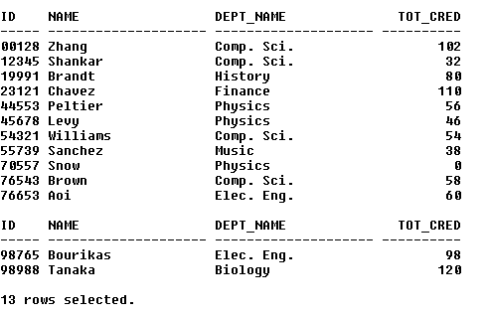

2. Find the department names of instructors.

select name, dept_name from instructor;

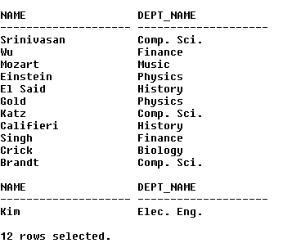

3. Find the names of all the instructors from Biology department.

select name from instructor where dept_name like 'Biology';



4. Find the names of all instructors in the Computer Science department who have salaries greater than $70000.

select name, salary from instructor where dept_name like 'Comp. Sci.' and salary > 70000;

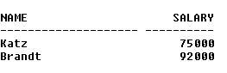

5. Find the names of courses in Computer science department which have 3credits

select title from course where dept_name like 'Comp. Sci.' and credits like 3;



6. Find the names of the instructors, their present salaries and the resulting salaries if they were given a 10% raise.

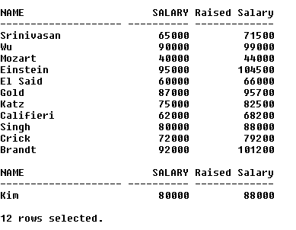select name, salary, (salary*1.1) as "Raised Salary" from instructor;

7. Find the names of instructors with salary amounts between $90000 and $100000.

select name, salary from instructor where salary between 90000 and 100000;

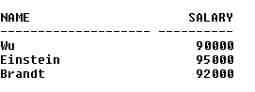

8. Find all instructors whose salary is unknown.

select * from instructor where salary is null;



9. Find the names of all departments whose building name includes the substring 'Watson'.

select dept_name, building from department where building like '%Watson%';

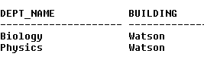

10. Find departments whose names contain the string "sci" as a substring, regardless of the case.

select * from department where lower(dept_name) like '%sci%';



11. List the names of all instructors in the Physics department in alphabetic order.

select name from instructor where dept_name like 'Physics' order by name asc;

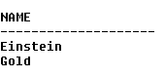

12. List the entire instructor relation in descending order of salary. If several instructors have the same salary, order them in ascending order by name.

select * from instructor order by salary desc, name asc;

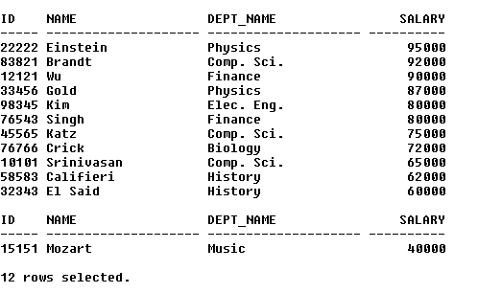

Write SQL queries for retrieving data from multiple tables using Joins:

1. Find all possible combinations of instructors and the courses they teach.

select i.id, i.name, c.course_id, c.title from instructor i, course c, teaches t where i.id = t.id and t.course_id = c.course_id;

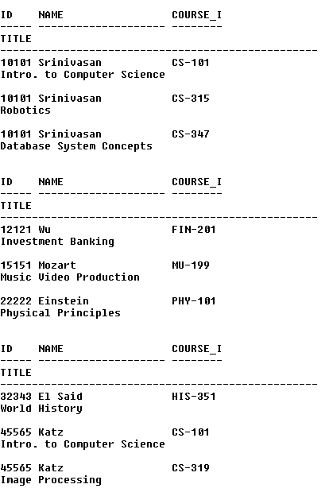

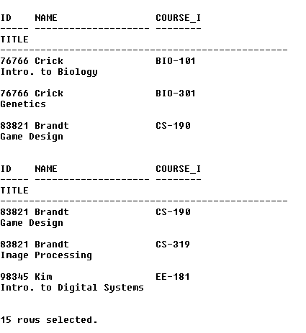

2. Retrieve the names of all instructors, along with their department names and department building name.

select i.name, i.dept_name, d.building from instructor i, department d where i.dept_name = d.dept_name;

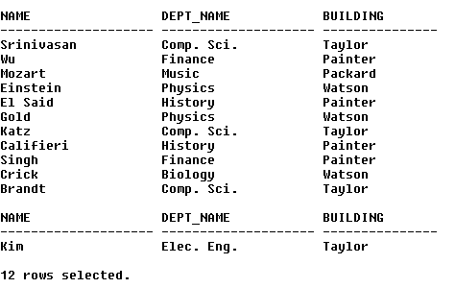

3. Find the names of instructors who have taught at least one course.

select distinct i.id, i.name from instructor i, teaches t where i.id = t.id;

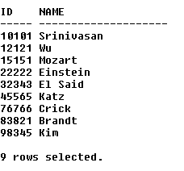

4. For the student with ID 12345 (or any other value), show all course_id and title of all courses registered for by the student.

select s.id, c.course_id, c.title from student s, course c, takes t where s.id = '12345' and s.id = t.id and t.course_id = c.course_id;

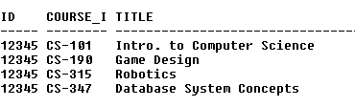

5. Find instructor names and course identifiers for instructors in the Computer Science department.

select distinct i.name, t.course_id from instructor i, teaches t where i.dept_name like 'Comp. Sci.' and i.id = t.id;

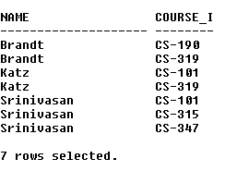

6. For all instructors in the university who have taught some course, find their names and the course ID of all courses they taught.

select distinct i.name, t.course_id from instructor i, teaches t where i.id = t.id;

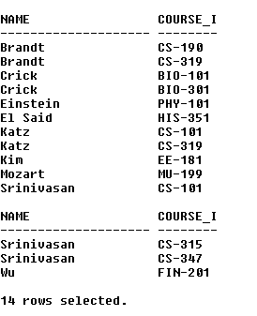

7. Find the names of all instructors whose salary is greater than at least one instructor in the Biology department. Or Find the names of all instructors who earn more than the lowest paid instructor in the Biology department.

select name from instructor where salary > (select min(salary) from instructor where dept_name like 'Biology');

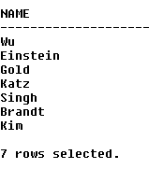

8. Find full details of instructors who teach at least one course.

select distinct i.* from instructor i, teaches t where i.id = t.id;

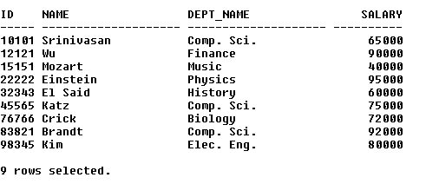

9. Find the instructor names and the courses they taught for all instructors in the Biology department who have taught some course.

select distinct i.name, c.title from instructor i, course c, teaches t where i.dept_name like 'Biology' and i.id = t.id and t.course_id = c.course_id;

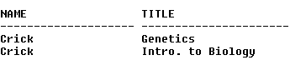

10. Find the set of all courses taught either in Fall 2009 or in Spring 2010, or both.

select course_id from teaches where (semester like 'Fall' and year like 2009) or (semester like 'Spring' and year like 2010);

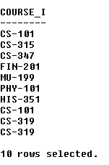

11. Find all courses taught in the Fall 2009 semester but not in the Spring 2010 semester.

select course_id from teaches where (semester like 'Fall' and year like 2009) and not (semester like 'Spring' and year like 2010);

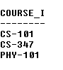

12. Find the names of all students who have taken any Comp. Sci. course ever. (there should be no duplicate names)

select distinct s.name from student s, takes t, course c where s.id like t.id and t.course_id like c.course_id and c.dept_name like 'Comp. Sci.';

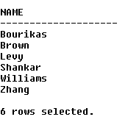

13. Display the IDs of all instructors who have never taught a course. (Don’t write nested query)

(select id from instructor) minus (select id from teaches);

